Assignment 3

Writing a Basic Command Shell

Author: Brian Crites

**This project must be done in a group of two**

# Github setup

The first part of assignment to is to update your github ‘Projects’. You will add a new project, call it ‘Assn 3 -- Test Commands’ with the same 3 columns, ‘Backlog’, ‘In Progress’, and ‘To Deploy’. Now, after reading the assignment specifications, create manageable sized **user stories**. Each of these user stories should be logged as an **issue** on github, labeled as an **enhancement.** They should start in the ‘Backlog’ column. You then want to assign the first 2 or 3 user stories to each of the group members. *Note: you can assign issues to contributors*. The first issue each member decides to work on should be moved to the ‘In Progress’ column. Each user will want to track their work through the ‘Projects’ Kanban board and resolve the issue when they complete it. After completing all their assigned user stories they can assign themselves new ones and begin working on them.

# Coding Requirements

## The Test Command

For this assignment you will add the test command to your rshell, as well as its symbolic equivalent [ ]. The square brackets [ ] are actually set up as the test command in bash, you can [read about it here](http://wiki.bash-hackers.org/commands/classictest) and try it out on your own. This command returns 0 (TRUE) if the test succeeds and 1 (FALSE) if the test fails. This command is very useful for writing conditions that can be combined with && and || to write more complex bash command structures.

**IMPORTANT**: You cannot use execvp to run the test command as you did in assignment 1. You must write the functionality yourself.

Your subset of the test command should allow the user to run the command using the keyword test

$ test -e test/file/path

Additionally, your rshell should allow the user to use the symbolic version of the command

$ [ -e test/file/path ]

You command should also allow the user to run tests using the following flags

-e checks if the file/directory exists

-f checks if the file/directory exists and is a regular file

-d checks if the file/directory exists and is a directory

If a user does not specify a flag, then the -e functionality will be used by default.

You will also add an extra feature that the test command currently does not have. Your test command will print out to the terminal if it evaluated to True or False

If the command test -e /test/file/path evaluates to True, then print display the following

(True)

And likewise, if the above command evaluates to False, then print False in the same manner

(False)

Additionally, your test command should work with the connectors && and || that you have written previously in assignment 2, as well as all other functionality from assignment 2.

$ test -e test/file/path && echo “path exists”

- or -

$ [ -e test/file/path ] && echo “path exists”

This will check if path exists at /test/file/path, and if path does exist will print “path exists”.

When your input requires you to have multiple outputs, simply print the (True) or (False) labels as they are evaluated, so the above command (assuming the path exists) would print

(True)

path exists

Your test function should be designed to work with both full directory paths and relative directory paths. In order to create this command, you will need to use the stat() command, which [you can read about here](http://linux.die.net/man/2/stat). You will need to use the stat() function along with the S_ISDIR and S_ISREG macros in order to implement all the flags required for this program.

## The Precedence Operators

Additionally, you will implement parentheses ( ) as precedence operators in your rshell. The parentheses ( ) operators are used to change the precedence of the returns of commands, connectors, and chains of connectors. For example

$ echo A && echo B || echo C && echo D

Would print the following

A

B

D

However, we can add parentheses to change the precedence of the connectors

$ (echo A && echo B) || (echo C && echo D)

which would print

A

B

This is because the parentheses change the precedence, so that when (echo A && echo B) returns true (since it execute correctly) to the || operator then it will not run the entire group (echo C && echo D) since the parentheses have now grouped these commands together. Note that if for some reason echo A failed, echo B would not execute, and (echo C && echo D) would be executed.

If you are unsure about how the parentheses will change how a set of commands runs, try out some examples in your terminal.

**IMPORTANT**: While the above example only shows a single parenthese, you must account for multiple nested parentheses in your implementation.

**IMPORTANT**: If there is an uneven amount of parentheses, you should simply error gracefully.

# Submission (TBA)

Create a branch called basicCommand off your main project repo. Do all of your work under this branch. When finished, merge the exec branch into the master branch, and create a tag called assn3

**NOTE:** git push will not automatically push tags to your repository. Use git push origin assn3 to update your repository to include the assn3 tag.

To download and grade your homework, the TA will run the following commands from the hammer server:

$ git clone https://github.com/yourusername/rshell.git

$ cd rshell

$ git checkout assn3

$ make

$ bin/rshell

**IMPORTANT:** You should verify these commands work for your repository on hammer.cs.ucr.edu to verify that you've submitted your code successfully. If you forget how to use git, two students from previous cs100 courses (Rashid Goshtasbi and Kyler Rynear) [made video tutorials](https://izbicki.me/blog/videoguide-for-github-vim-bash.html#tags) on the git commands needed to submit your assignments via Github.

**Do not wait to upload your assignment to Github until the project due date**. You should be committing and uploading your assignment continuously. If you wait until the last day and can't figure out how to use git properly, then you will get a zero on the assignment. NO EXCEPTIONS.

You will also need to create a file for submitting your partner and github information. Create a [JSON](http://www.json.org/) file with the following information: you and your partner’s name, email, and id as well as the github url of your assignment’s repository. Save the file as **assn3.json** and submit it to iLearn’s to Assignment 3 submission link.

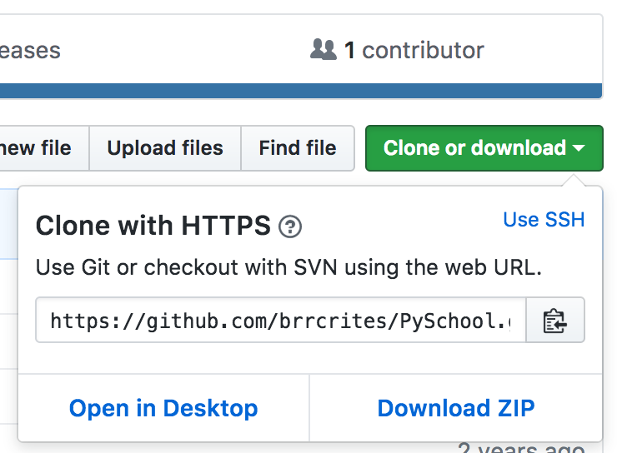

Make sure you are using the HTTPS GitHub link (shown above), not the SSH link when creating your JSON submission file. This link is accessible from the front page of your GitHub repository.

**Here's an example file:**

{

"github_url": "https://www.github.com/busrac/rshell.git",

"partners": [

{

"name": "Busra Celikkaya",

"email": "bceli001@ucr.edu",

"id": 861000000

},

{

"name": "Lam Le",

"email": "lle018@ucr.edu",

"id": 861000000

}

]

}

You **MUST** validate that your JSON is correct using a [JSON linter (like this one)](https://jsonlint.com/) before you submit it. Invalid JSON will result in a zero for this assignment. Your repository should be public, however if you prefer to have a private repository please email the instructor for additional information on adding collaborators.

# Project Structure

You must have a directory called src which contains all the source code files for the project.

You must have a Makefile in the root directory. In the Makefile you will have two targets. The first target is called all and the second target is called rshell. Both of these targets will compile your program using g++ with the flags: -Wall -Werror -ansi -pedantic.

You must NOT have a directory called bin in the project; however, when the project is built, this directory must be created and all executable files placed here.

You may also optionally have a .gitignore file to automatically stop generated files from being uploaded to your remote repository.

You must have a LICENSE file in your project. You may select any open source license. I recommend either GPL or BSD3.

You must have a README.md file. This file should briefly summarize your project. In particular, it must include a list of known bugs. If you do not have any known bugs, then you probably have not sufficiently tested your code! Read [this short intro](https://robots.thoughtbot.com/how-to-write-a-great-readme) to writing README files to help you. You must use the Markdown formatting language when writing your README.

You must have a directory called tests. The directory should contain a bash script that fully tests each segment of the program mentioned in the rubric. This means that for a completed project, you should have the following files (with these exact names):

test_test.sh #tests for the test command

precedence_test.sh #tests for precedence operators

commented_command.sh #tests commands with comments

exit.sh #tests exit and commands with exit

Each of these files should contain multiple commands in order to fully test each functionality. Proper testing is the most important part of developing software. It is not enough to simply show that your program works in some cases. You must show that it works in every possible edge case

# Coding Conventions

Your code must not generate any warnings on compilation.

You must follow the [CalTech coding guidelines](http://courses.cms.caltech.edu/cs11/material/cpp/donnie/cppstyle.html), as stated in the syllabus.

Your final executable must have no memory leaks.

# Testing

Proper testing is the most important part of developing software. It therefore will have a very large impact on your grade.

It is not enough to simply show that your program works in some cases. You must show that it works in every possible edge case. **That means you must try to write test cases that will break your program!**

If you are unsure if your test cases are sufficient, ask one of the instructors to review them before the deadline.

# Collaboration Policy

You **MAY NOT** look at the source code of any other student.

You **MAY** discuss with other students in general terms how to use the unix functions.

You are **ENCOURAGED** to talk with other students about test cases. You are allowed to freely share ideas in this regard.

You are **ENCOURAGED** to look at [bash's source code](https://www.gnu.org/software/bash/) for inspiration.

# Grading

**Rubric**

|  |  |
| --- | --- |
| **Points** | **Description** |
| 5 | Code comments |
| 5 | Following style guidelines |
| 5 | Github management |
| 20 | Sufficient test cases |
| 35 | Test operator (including integration with precedence and past requirements) |
| 30 | Precedence operators (including integration with test and past requirements) |
| 100 | Total |

**IMPORTANT**: Your project structure is not explicitly listed in the grading schedule above, however not following the correct structure will result in a 20 point deduction.

**IMPORTANT**: Projects that do not correctly compile as described above will receive no points.